If Shakespeare Wrote Pop Songs
The Huffington Post | By Maddie Crum
- Email

Posted: 08/27/2014 8:23 am EDT Updated: 08/27/2014 8:59 am EDT
As the debate wages on about the Bard's relatability -- and whether or not relatability matters to begin with -- a hilarious Tumblr has surfaced that translates modern-day pop songs into Shakespearean sonnets.
Every wonder what Taylor Swift's newest album would sound like in iambic pentameter? Us neither, but the outcome is, unsurprisingly, joyous. After all, he who gave us the wide-eyed Miranda ("O brave new world!") and the naive Juliet was pretty great at capturing the dramatic pitfalls of youthfulness.
The rest of the lyrics on Pop Sonnets (ha!) are great, too. You'd expect "Call Me Maybe" written in 1600s English ("Now our acquaintance, only moments sown/ has made my heart fair logic cast away") to be a funny juxtaposition, but it's more than that: it's a catchy, natural reworking that rolls off the tongue.
Below are 6 Top 40 songs, rewritten as Shakespeare sonnets:
- "Call Me Maybe"
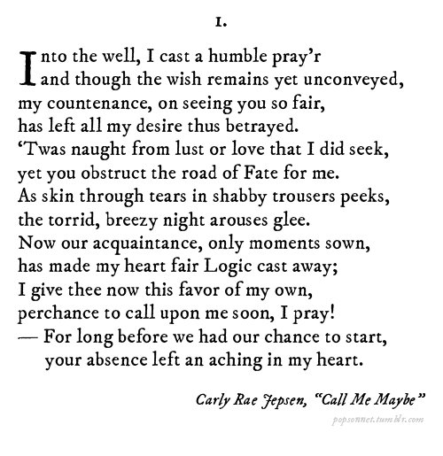
- "Party in the USA"
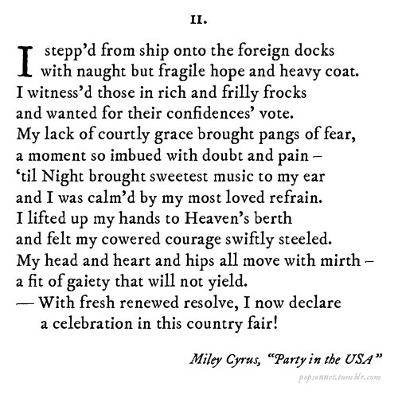
- "Single Ladies (Put a Ring on It)"
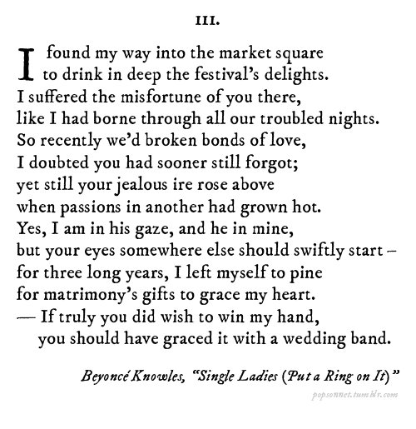
- "I Love It"
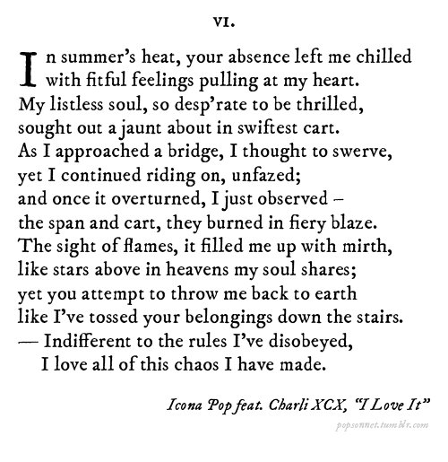
- "We Are Never Ever Getting Back Together"
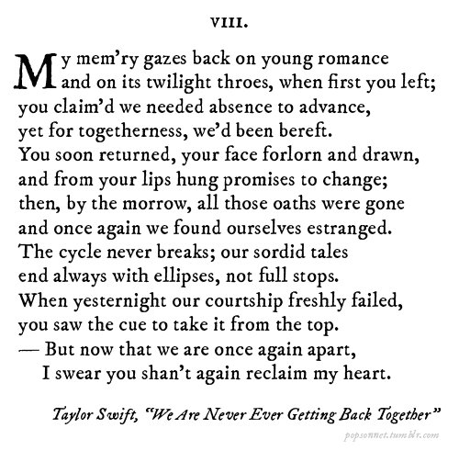
- "Get Lucky"
