Research
Packet

Northeast magnet high school
Created by Mrs. Simmons
Adapted by Mr. Bell

Created February 2013

Table of contents

RESEARCH VOCABULARY 3
WHAT A RESEARCH PAPER DOES 4
WHAT A RESEARCH PAPER AVOIDS 4
EVALUATING RESOURCES 5
SOURCE CARD FORMS 6
NOTE CARDS 7
PLAGIARISM 8
WHAT A THESIS STATEMENT DOES 9
WHAT A THESIS STATEMENT AVOIDS 9
OUTLINE PREP 1
CREATING YOUR OUTLINE 1
SAMPLE OUTLINE 2
INTERNAL CITATION 2
TSAC BODY PARAGRAPHS 3
WORKS CITED 4
SAMPLE WORKS CITED 4

RESEARCH VOCABULARY

- Synthesis: combining separate elements to form a coherent whole
- Evaluation: examination of and making judgment about the value of a source
- Draft: a preliminary version of a plan, document, or picture
- Parenthetical documentation: acknowledgement of the sources right in the text at the point where you use them in your paper – documentation is enclosed in parentheses at the point where the reader needs to know the source of the information you are presenting
- Revise: to change or modify the text of your paper
- Bibliography: a list of all the print, audio, and visual sources available for the topic
- Works Cited: a list of the complete information about the resources you mention within the text so that anybody who wants to look at what you used can find the same sources
- Plagiarism: using someone else’s words or ideas without giving proper credit to the person who devised them
- Criticism: weighing and judging the quality of something – should include both positive and negative comments
- Commentary: the expression of opinions or explanations about information given
- Logic: a reasoning process without fallacies
- Primary Source: sources which come straight from the people or works you are researching and are therefore the most direct kinds of information you can collect – they are firsthand observations and investigations (Examples: diaries, letters, interviews, autobiographies)

- Secondary Source: sources which are one step removed from the original and are often an examination of a study someone else has made on a subject – or an evaluation of, commentary on, or summary of primary material
- Skimming: looking through a work quickly in order to get an overall impression; can serve two purposes: to get at the main idea of a selection without undue attention to its details which may distract OR to tell if there is enough relevant information in the source to read more closely
- Scanning: looking for specific information quickly, without reading word-for-word or phrase-by-phrase; looking for key words, names, dates, specifics that indicate you have found useful information on which to take notes
- Thesis Statement: a specific declaration in statement from which summarizes the point of view you will take in your paper
- Topic Outline: ideas in the orderly plan written in words or phrases or dependent clauses
- Sentence Outline: ideas in the orderly plan written in grammatically complete sentences
- Paraphrase: statement in your own words, phrase-by-phrase, of the original passage – follows the original closely with the same organization and the same approximate length
- Fact: a statement that can be verified by evidence from senses: something a person can see, hear, taste, touch, or smell
- Inference: an educated guess based on at least one, but usually several, facts
- Summary: statement in your own words of the main idea of the passage – tells only what the author has said and may not include your own interpretation or comment on the meaning

WHAT A RESEARCH PAPER DOES

- Synthesize, judge, interpret, and evaluate
Your discoveries consist mostly of the ideas, knowledge, and actual words of the people who have written, spoken, or made pictures about the subject you are investigating. They are likely to come from both print and non-print sources. But all that collected material only has value because YOU weighed your discoveries and drew logical conclusions from them.
- Reveals your originality
The paper resulting from your study, evaluation, and synthesis will be a TOTALLY NEW CREATION, something you originate. In a carefully crafted research paper, your own hand and thought – your originality – are evident.
- Acknowledges all sources you have used.
Documentation and acknowledgement of what is NOT original is so basic to research papers that a whole series of customs and conventions has developed for crediting what you borrow from other people. Ethical behavior demands that you acknowledge the sources that contributed to your work. Finding information and making it available to others, whether in writing, orally, or in films, is HARD WORK! Acknowledging that debt to others is only right and fair!!!

WHAT A RESEARCH PAPER AVOIDS
- Summary
A summary cannot fit the description of a research paper for two reasons: you can’t select materials, and the organization cannot be your own because a summary must always follow the structure of the original source.
- Ideas without your criticism
To repeat, uncritically, what others have said is merely to report information already available elsewhere.
- A series of quotations
Quotations have an important place in a research paper because they are the words of experts in the field. However, if your paper is nothing more than a series of quotations, the “you” of the synthesis is missing: the work certainly gives no evidence of your originality.

- Unsubstantiated personal opinion
The research paper topic is not one that lends itself to opinions without extensive, factual basis.
- PLAGIARISM
Copying or accepting another person’s work without properly acknowledging it, whether the work is published or unpublished, professional or amateur, is NOT research. IT IS PLAGIARISM, and it is illegal, and it shows ignorance.

EVALUATING RESOURCES
Not all sources are created equal nor are of equal quality. Do not assume that something is truthful or trustworthy simply because it appears in print or on the Internet. Students must be especially careful in using online sources. Internet sources must be held to the same high standards of scholarly integrity that we impose on material in the library. The problem with online resources is that unlike our library, no one is in charge of the World Wide Web. If you were to type King Lear into Google, a listing from Yale University could come up right underneath one from my Aunt Kaylene!
There are several items a researcher can look at to see if the information they’ve found is valuable. For internet searches, we need to know what the abbreviations stand for at the end of every web address. You should be most careful with .com and .net endings.

Web Abbreviations and Meanings
.com | Commercial – product information and sales; personal sites; some combinations of products and information, such as World Book Online
.edu | Education – information about schools, courses, campus life, and research projects; students’ and teachers’ personal sites
.gov | United States government – official sites of the White House, NASA, the FBI, and other government agencies
.mil | United States military – official sites of the Army, Navy, Air Force, and Marines, as well as the Department of Defense and related agencies
.net | Network – product information and sales
.org | Organization – charities, libraries, and other nonprofits; political parties

Things to look for when evaluating website usefulness:
- Currency
  - Is the information up to date? Is the information considered current?
  - Can you tell when the site was created or last updated?
  - Do the links work?
- Relevance
  - Is the topic adequately covered?
  - Is it covered at an appropriate level for your needs?
  - Who is the intended audience?
- Authority
  - Who is the author? What are his/her credentials?
  - Is the affiliating organization reputable?
  - Is there a way to contact this person/organization?
- Authenticity
  - Is the information correct?
  - Can the information be verified by other sources (this means that the same information shows up many times, enforcing the idea that it must be true)?
  - Are there spelling, grammatical, typographical errors?
- Purpose
  - Is the purpose of the site clear (entertain, persuade, inform, etc.)?
  - Is it objective? Does the point of view appear impartial?
  - Are there many ads or links leading to unrelated topics?

SOURCE CARD FORMS

Handwritten cards require underlining to indicate italics. Source cards are DOUBLE-SPACED.
More citations available at http://owl.english.purdue.edu/media/pdf/20110928111055_949.pdf.

Format
- Book
Last, First. Title of the Book. City published in: Publisher, Year. Print.

- Article from Ebsco
Last, First. “Article.” Magazine originally published in. Volume. Issue.(Year):Pages. Ebsco Host. Web. Date you viewed it.

- Article from an anthology
Last, First. “Article.” Anthology Title. Ed. (editor) First Last. City Published in: Publisher, Year. Pages. Print.

- Article from internet with author
Last, First. “Article.” Title of Website. Organization, Year. Web.Date looked at.

- Article from internet without author
. “Article.” Title of Website. Organization, Year. Web.Date looked at.

Examples
- Book
Pollan, Michael. The Omnivore’s Dilemma. New York: Penguin Group, 2006. Print.

- Article from Ebsco
Brinkworth, Russelll. “First year expectations.” Higher Education 58.2 (2009):157-73. Ebsco. Web. 17 Aug. 2009.

- Article from an anthology
Harris, Muriel. “Talk to Me.” Helping Writers. Ed. Ben Rafoth. Portsmouth: Heinemann, 2000. 24-34. Print.

- Article from internet with author
Smith, James. “Media Giants.” Frontline: The Merchants of Cool. PBS Online, 2001. Web.7 Feb. 2006.

- Article from internet without author
“Media Giants.” Frontline: The Merchants of Cool. PBS Online, 2001. Web.7 Feb. 2006.

NOTE CARDS

The PARAPHRASE CARD is a restatement of exactly what was written in the original source but restated in different words. Quotation marks indicate when specific phrases from the original were kept. The paraphrase is different from the summary in that nothing can be left out by condensing information as when summarizing. Also, the paraphrase absolutely must be written in different words – the words of the researcher himself. Unlike a summary, it will NOT be shorter than the original.
Source card #
#4
1925, Dreiser’s reputation firmly established. Reading public viewed him as one of the main contributors to downfall of the “genteel tradition” in American literature. He was “supreme poet of the squalid.” He looked beneath bright surface of American life and values and described frightening and tragic element, “ugly realities,” often overlooked by other writers.

115-16 P

Paraphrased

The QUOTATION CARD gives the exact words found in the text or item being used as a source. It may be used to repeat a quotation that the source itself was quoting from somewhere else. It may also be used because the research feels that the words in the source say it better than he or she can summarize or paraphrase them. Quotation cards should not be overused. It is vital to designate exactly who is being quoted when making this kind of card.
Paraphrase
Page #
Page #
Source card #
#4

Dreiser was considered “the most powerful and effective destroyer of the genteel tradition that had dominated popular American fiction in the post-Civil War period.”
--Richard Freeman

115-16 Q

Quotation is from author.
Quoted

NOTE: Remember to number cards consecutively on the back side of each, and include your initials and class hour on each as well. Also, use an introductory identification card on the top.
- DO put a source reference (use the source card #) on EVERY card.
- DO record only ONE kind of information—paraphrase or quotation—on each card.
- DO include the page number where you found the information.
- DO use ellipses (…) when you choose to omit words within a quoted sentence. If you leave out words at the end of a quoted sentence, use the ellipses plus a final period (….).
- DO put your initials and class hour on the back of each note card, and DO number each card consecutively as you complete it, also on the back of the card.
- DON’T use more than 1 or 2 block quotes ( > 4 lines). Be sure to have at least 1 long quote.
- DON’T continue information from one card to another.

PLAGIARISM

To plagiarize means “to commit literary theft’ and to “present as new and original an idea or product derived from an existing source” (Merriam-Webster’s Collegiate Dictionary [11th ed.; 2003; print]). Plagiarism is the failure to give appropriate acknowledgement to the author. Even repeating or rephrasing another person’s words without giving proper acknowledgement is plagiarism.

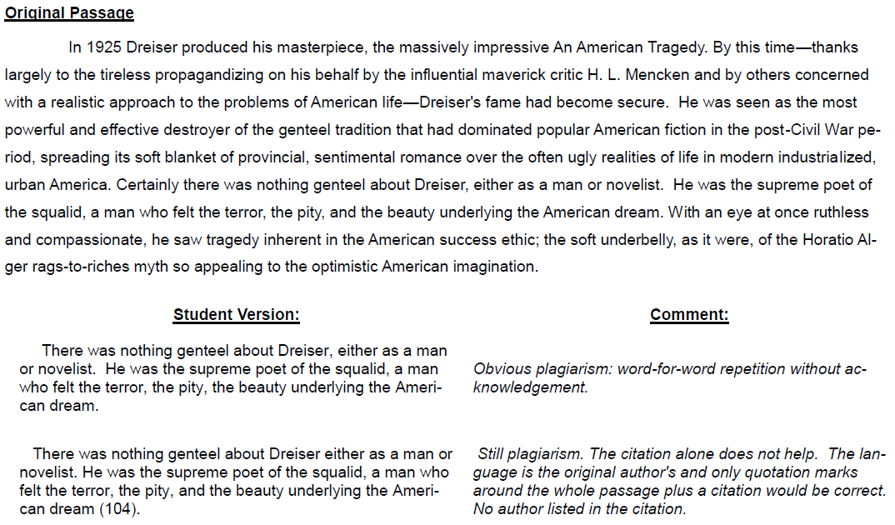
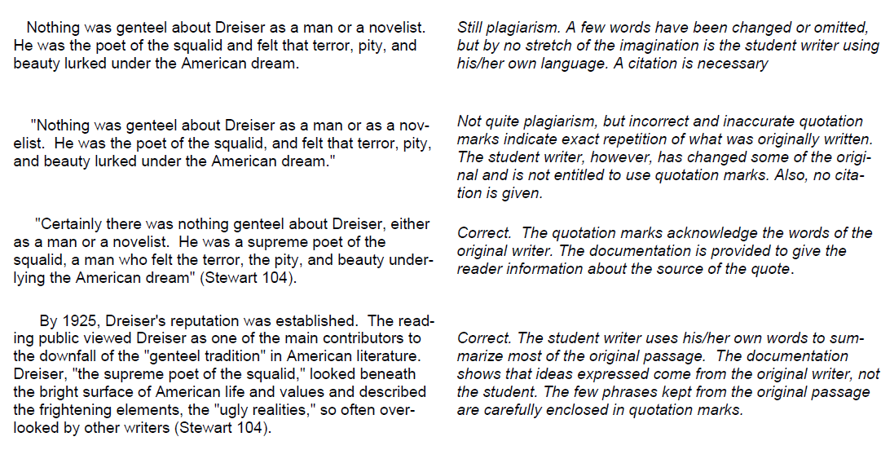

WHAT A THESIS STATEMENT DOES
A thesis statement is a specific declaration that summarizes the point of view you will take in the paper. Thesis Statement = SUBJECT + THE WRITER’S ATTITUDE (significant to the reader)

- The thesis statement is limited so it can give direction to the paper.
The thesis statement sets limits on the scope of what you will cover, and it should be accurate.
Unlimited: Barriers hinder the disabled.
Limited: Architects are now aware that people with physical, audio, and visual limitations need easy access to public buildings and within them as well.
- The thesis statement is specific.
Anyone reading the thesis should know what the paper is about. Vague words will not do.
Vague: Some TV programs are bad for children.
Specific: Television programs depicting violence numb children’s tolerance for and sensitivity to real-life acts of violence against people.

Examples

WHAT A THESIS STATEMENT AVOIDS
Sometimes it is easier to understand an idea when you can see what it isn’t, rather than only what it is. The following four statements tell what a thesis statement is NOT.

- Promising what will be in the paper
Wrong: In this paper I am going to show how the ancient Egyptians were able to build so many huge temples and tombs.
Better: The ancient Egyptians were able to build so many temples and tombs because their farmers had time to do other kinds of work. Their religion encouraged people to do work that glorified their gods and pharaohs, and busy people were necessary for political and economic stability.
- Only saying the topic
Wrong: the fitness craze
Better: The fitness craze in the United States has resulted in a population more aware of the role of exercise and good eating habits in lengthening people’s lives and making them more productive.
- Adding a few words added to a title but not forming a complete sentence
Wrong: Money and Lives in the Space Program
Better: The money spent and the human lives lost in the space program do not justify its continuance.
- A question cannot serve as a thesis statement because it is not a statement.
Wrong: What will Maya Angelou’s place be in literature?
Weak: Maya Angelou will have secured a place in several genres of literature.
Better: Maya Angelou is an accessible writer whose prose and poetry will long be read because they deal with human conditions, and not just with African-American issues.

OUTLINE PREP
- Lay out all of the MAIN TOPICS (divisions) first. Most research projects will support THREE main topics.
  - Write these three categories on paper.
  - Now organize your notecards into three stacks, corresponding to these three main categories. If some do not fit, create a fourth stack which can be used or discarded later.
- Starting with one stack of notecards, decide upon the SUBTOPICS/categories/divisions that you think are appropriate and then list them under the relevant main topic, using capital letters.
  - As a rule of thumb, there should be at least three subtopics under a main topics.
  - Follow through with the other stacks of notecards just as above.

CREATING YOUR OUTLINE
- Be absolutely sure that every line in your outline supports the thesis statement. If something does not work, alter either the outline or the thesis statement.
- Make sure all lines of equal rank “line-up” with each other.
- Your final outline will need to include the following:
  - MLA heading
  - A title at the top; the same title you will use for your paper
  - Your thesis statement underneath the title
  - Roman numeral I. as the Introduction
  - At least three Main Topics for the body of your paper (II., III., and IV.)
  - Every Main Topic broken into at least two Subtopics (A. and B.)
  - Every Subtopic broken into at least two Supporting Details (1. and 2.)
  - The final Roman numeral as the conclusion (V.)
  - Everything double-spaced
  - All entries lined up
  - All entries beginning with a Capital letter
  - I highly suggest matching your notecards to pieces of information in your outline. This will keep you from forgetting which information you meant to use in specific locations.

SAMPLE OUTLINE
Solar Energy to Heat the Water
THESIS STATEMENT: Solar energy will provide a dependable, practical power source at significant cost savings when used for water heaters in New England homes.

- Main topic introduction
  - Catchy beginning
  - General info
  - Thesis
- Costs for operating a water heater
  - Conventional types
    - Electric
    - Gas
  - Escalating costs
    - 1960, 70, 80, 90, 00
      - Installation
      - Maintenance
    - Projected for 2010
      - Installation
      - Maintenance
- Costs for solar energy-powered heater
  - Initial costs
    - Equipment
    - Modification of house
  - Maintenance costs
    - Current prices
    - Projected prices
  - Available subsidies and reimbursements
    - Governmental
    - Environmental groups
- Dependability of solar energy
  - Functioning of unit
    - Lower maintenance
    - Fewer regulations
  - Storage capacity (in case of poor weather)
    - Solar panels
    - Storage tanks
- Main topic conclusion
  - Restate thesis
  - Sum up main points
  - Strong ending that makes the reader think

INTERNAL CITATION

TSAC BODY PARAGRAPHS

WORKS CITED
- Double-space all information
- Alphabetize all entries according to the author’s last name. If a source has more than one author, alphabetize by the first author’s last name.
- If you use more than one source by the same author, do not list the author’s name again. Instead, use three hyphens and a period [---.] in place of the name in the second and any subsequent entries.
- If no author is listed, alphabetize by the first important word of the title.
- Use a hanging indent. Begin each new citation at the left margin and indent all other lines of the entry. (After you have typed up your Works Cited, select all, right click, click on Paragraph, and choose “Hanging” for indention).
- Stay within the appropriate top, bottom, and side 1” margins.
- Do not underline the title Works Cited.

SAMPLE WORKS CITED

