Good Night  and  Good Luck  Questions/Main Ideas | Name: __________________________________________________________ Class: __________________________________________________________  Period:__________________________________________________________  Date:___________________________________________________________  Notes:
What are people signing? Why?
Why do they want to cover the officer?
What is the consequence for running it?
What do the newspapers say?
What threat does someone tell Joe?
What evidence does Murrow use in his next piece about McCarthy?
What does McCarthy say in his rebuttal?
What does Murrow say to the attacks?
What happened to the air force officer?
What does Paley require Murrow to do?
What is the threat to journalism?

Characters | Notes
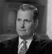 | Sig Mickelson:
 | Edward R Murrow:
 | Fred Friendly:
 | Shirley Wirshba:
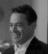 | Joe Wirshba:
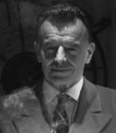 | Don Hollenbeck:
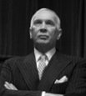 | William Paley:
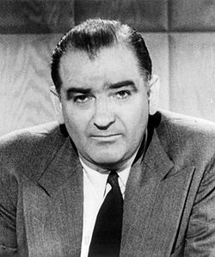 | Joseph McCarthy:
Summary

