Step 1) Press Control A to select everything.
Step 2) Press the no space box.
Step 3) Change to Times New Roman and 12 pt font
Step 4) Press Control 2 to double space

Step 5) Heading is where the cursor blinks on the first line.
Step 6) Enter your name, the teacher name, the class, and the due date
Step 7) Press Control E for the next line to center your title, which is not the same as your topic
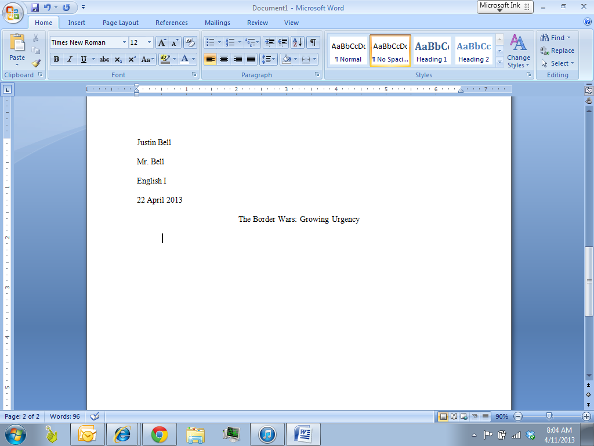

Step 8) Double click the space at the very top of the page.
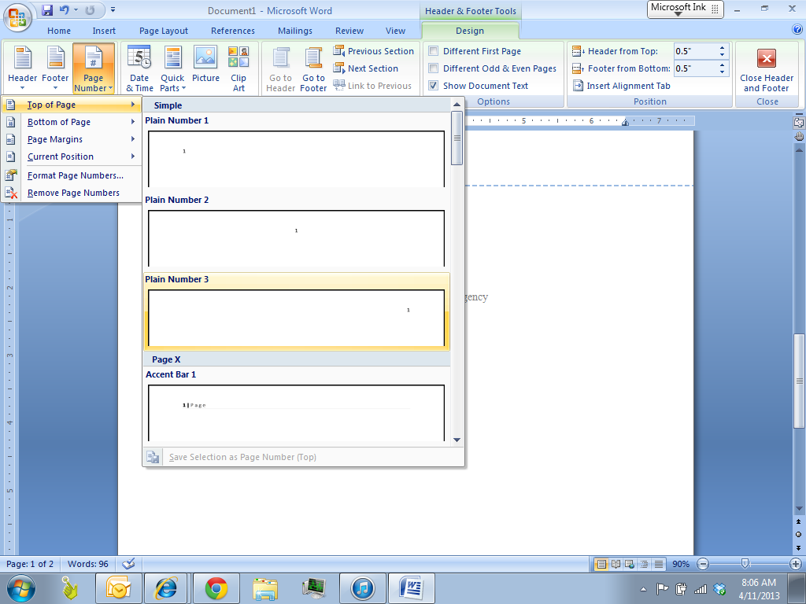
Step 9) Press Page number, then top of the page, and then the third box to place it on the right.

Step 10) Type in your last name in front of the number
Step 11) Click different first page
Step 12) Click close header and footer

