Homer sweet home... Archaeologists find 'Odysseus's island palace'

Evidence that the Odyssey and Iliad may be true after all

Archaeologists believe they have found the palace of Odysseus, the legendary Greek king of Ithaca and hero of Homer's epic poem.
They believe that the 8th BC century palace which they have discovered in Ithaca, in the Ionian Seas west of mainland Greece, proves that he was a real historical figure.
It is the only one of the palaces mentioned in Homer’s epic poems that hadn’t been found.
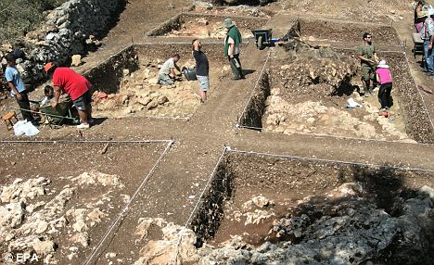
Greek archaeologists believe they have found an eight century BC palace on the island of Ithaca, fuelling theories that the hero of Homer's epic poem was real. The excavations have been made in the Aghios Athanassios area of the Ionian island
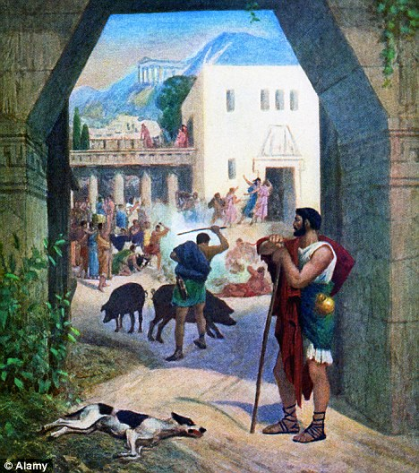
Legend: The story of the King of Ithaca's ten-year journey home is an enduring classic - now it seems that his home really existed
For many years, Homer's other epic The Iliad - telling the story of the protracted siege of Troy by the Greeks which culminated in the deployment of their Wooden Horse ruse - was regarded as a myth.
But then in the 1870s, the German archaeologist Heinrich Schliemann rediscovered the city in modern-day Turkey.
The views from the ruins found on the island of Ithaca by the University of Ioannina are exactly as described in The Odyssey, says Professor Thanassis Papadopoulos who led the team.
Known to the ancient Romans as Ulysses, the Greek hero famously took ten years to return home to Ithaca after the fall of Troy.
Enlarge 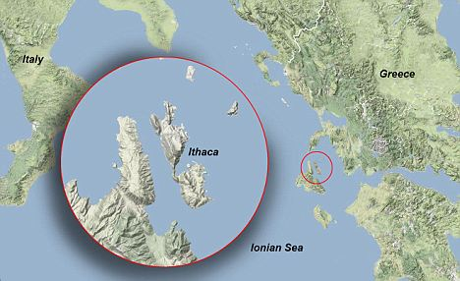
Archaelogists believe the palace which they have discovered in Ithaca, in the Ionian Seas west of mainland Greece, proves that Odysseus - known to the ancient Romans as Ulysses - was a real historical figure
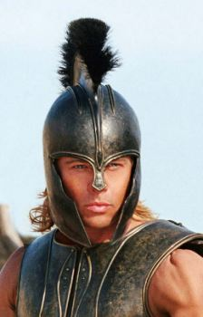
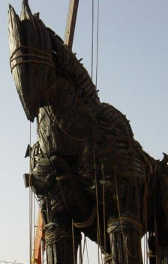
Warriors such as Achilles (here portrayed by Brad Pitt in the film Troy) were admired by the Greeks but it was Odysseus's cunning, typified by the famous Wooden Horse, that led to the eventual fall of Troy
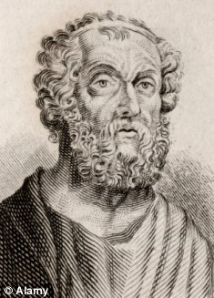
Legendary: Greek poet Homer
'According to evidence so far, which is extremely significant, and taking under consideration scientific reservations, we believe we are before the palace of Odysseus and Penelope; the only one of the Homeric-era palaces that has not yet been discovered,' said Professor Papadopoulos.
On his journey, he was shipwrecked and encountered many obstacles before returning to Ithaca, where he found his wife, Penelope, under pressure to remarry from a host of suitors. He then has to reassert his rightful place as king.
However Professor Papadopoulos faces an uphill struggle persuading some of his colleagues that he really has discovered the home of Odysseus.
One British researcher, Robert Bittlestone, insists that Homer's description of ancient Ithaca bears little resemblance to the island that now has its name and that Odysseus's kingdom was located on the isle of Cephalonia.
But Adriano La Regina, an Italian archaeologist, has a more pragmatic approach: 'Whether this find has a connection with Ulysses or not is interesting up to a certain point, but more important is the discovery of the royal palace.'
http://www.dailymail.co.uk/news/article-1306042/The-legend-Homers-Odyssey-true-Archaeologists-palace-began.html

