The Masks Men Wear
by BRETT & KATE MCKAY on AUGUST 8, 2010 ·
in A MAN'S LIFE, ON MANHOOD

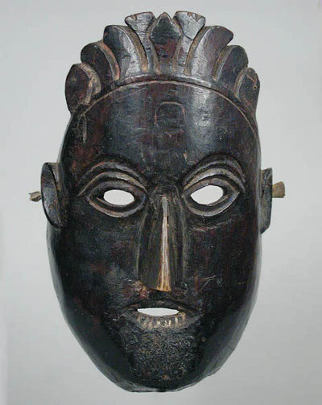
Anyone who has dressed up for Halloween knows the transforming effect donning a costume can have, and how exponentially stronger this effect is when it involves wearing a full mask. You feel mischievously free- free of self-consciousness, free to get in character and be someone or something else, free to get a little crazier than you normally would. There is a power in the donning of a mask and for thousands of years, tapping into this power was an essential part of the male experience. Putting on physical masks allowed men to drop the social, psychological “masks” they wore each day and express the more hidden sides of themselves. Now, with the tradition of physical masking having all but disappeared in civilized society, the false veneers of social masks have become permanently glued to the faces of many modern men.

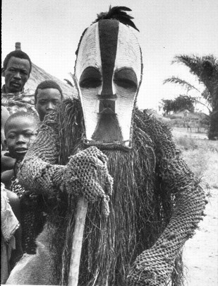
The Tradition of Masking
Since prehistoric times and all across the world, making and wearing masks has been almost exclusively the domain of men. Men donned masks for many of the rituals and celebrations that marked a tribe’s most important celebrations and transitions. Men wore masks during rites-of-passage, to ensure a bountiful hunt and harvest, to escort recently deceased spirits into the afterlife, and to mark times of renewal like the new year.
Masks helped primitive tribes deal with change and danger. Transitions and crises could threaten the unity of the tribe. The unchanging face of the mask was a symbol of stability and continuity, and the masquerades were thus used to convey meaning, purpose, and structure during these shifts.
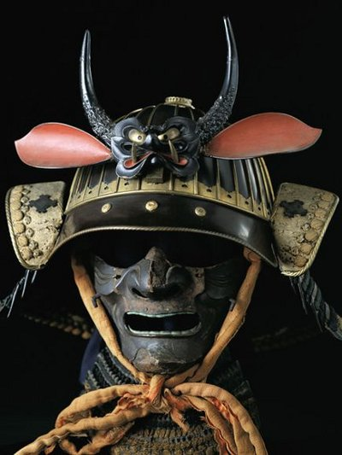
And of course, masks were and are not simply for symbolic use. They also serve as straightforward, functional headgear designed to protect the face. Ancient warriors like the samurai and medieval knights donned headgear and masks not only to protect their mugs, but to intimidate the enemy. Functional masks are the only type of mask to still enjoy widespread use today. From the helmets of football players and motorcycle riders to the masks of hockey goalies and doctors, these masks protect the face while also serving to get the wearer “in the zone.”

Of Masks and Men
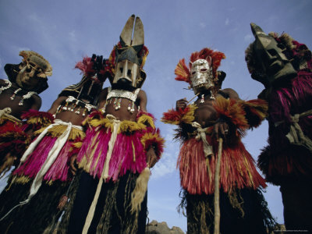
Masking’s masculine nature likely arose from its ancient connection to the hunt. Males also often dominated the spiritual life of the tribe, and donning a mask was believed to allow a man to transform himself into the spirit or deity the mask represented.
But masking served a deeper purpose for the male psyche as well. Men have always had to put on a psychological or social mask-a front to hide weakness from their rivals and adhere to a culture’s standard of flinty manliness.
Researchers who study primates, like baboons, have learned never to tranquilize a male in front of his rivals. Once the male goes down, his competitors see the opportunity to pounce on him and will viciously attack the helpless baboon. No such problem exists when researchers tranquilize female primates. One can see then why male primates that are sick or injured will put on displays of vitality and vigor when their rival is around, only to go back to licking their wounds when once again by themselves. Biologists theorize that perhaps our human ancestors dealt with same issue-they couldn’t appear vulnerable or their rivals would see an opening, an opportunity. So our male ancestors learned to hide weakness and act tough. But constantly putting up this front can be psychologically taxing.
By donning a physical mask, the men of old could drop the false facade and feel free to express the more hidden aspects of themselves. Masks were a way to connect with the wild man we’ve been talking about recently, to let loose without feeling fearful or self-conscious. Masks were avenues of transformation and self-discovery for men. They were empowering, allowing men to act out the drama of nature, spirit, and desire in a controlled environment.

The Social Masks of Modern Men
The male tradition of wearing physical masks has almost entirely disappeared in the developed world, with the exception of things like Halloween, Mardi Gras, and Carnival.
But the pressure for men to wear a social “mask” has not vanished. We are still generally expected to hide our weaknesses, on penalty of being labeled a sissy. We also sometimes wear masks of cynicism, coolness, aloofness, or of just generally being people we are not.
The tribal rituals of past times allowed men to drop these false social masks by donning a real mask. Without these reprieves, false social masks can become molded to our faces and become permanent parts of ourselves.
It is not that social masks do not have a healthy role to play in our lives. In Masks: Faces of Culture, the authors describe the transforming effect donning armor and a mask had on the warrior:
“fortified and impenetrable, he appeared ominous, daunting, and invincible, prepared to conquer the world. He exuded a look of rationality, domination, and control, totally disengaged from nature.”
Don’t we all want to feel and look like that from time to time?
Sometimes we need to be the rock of strength for those around us, even when we’re struggling ourselves. When you’re striding up to ask a girl out or sitting in a job interview, wearing a mask of self-assurance can help you come off better than your “normal” self. Putting on a social mask of certainty and strength gives confidence to those around you and makes you feel confident yourself. We see this when athletes put on their “game face,” or when a high-powered salesman takes on a different persona to make the hard sale.
The problem, however, is that some men keep wearing their mask even when the game is over.

The Temptation of the Social Mask
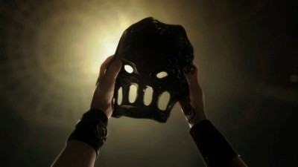
Ancient warriors wore masks as part of their defense-to protect themselves from the blows of their enemies as they defended their territory. Modern men wear the false social mask for a very similar reason-to shield themselves from being wounded by others, to protect their emotional territory from invasion and assault. They use the social mask to intimidate, mystify, and prevent others from getting too close. Their mask keeps others asking,“Who is this person? Does he mean me harm or good?”
But constantly donning a false mask is a cowardly way to deal with your fears. Instead of confronting them directly, you wall them off inside your true self, while allowing your alter ego to navigate the world. The mask acts as the buffer between you and others. This way people don’t insult or reject you, they don’t let you down, they simply deal with your false front while you’re hiding in the back. People can’t touch the real you. The mask puts distance between you and the world and allows you to spurn personal responsibility for your actions. Masks embolden people to do things they wouldn’t normally do-for good and ill. “It wasn’t me being a d-bag, that was The Situation!”

As discussed, the occasional use of a social mask can be healthy. But many men start to use it as a crutch and can’t take it off. Like Jim Carrey’s character in The Mask or the Green Goblin, the power of the mask becomes addicting. It’s easy to put on a mask to transform into someone else, but it’s harder to change who we really are. The mask becomes the source of our power and confidence instead of that power coming from within.

The problem with constantly putting on a false front is that the relationships we make while wearing it are inevitably inauthentic. People interact with your alter ego instead of the real you.Mad Men’s Don Draper is a perfect example of this. He tries to keep up a front of cool control and invulnerability in his relationships. His associate Harry Crane remarks, “Draper? Who knows anything about that guy? No one’s ever lifted that rock. He could be Batman for all we know.” The problem is not only that nobody knows Don, but that in pretending to be someone else (quite literally here) he doesn’t know himself either. He wants to change, but his real self and his false persona are so disconnected he doesn’t know how.

