The American Nightmare
We have everything the American Dream prescribed. So why aren't we happy?
By Lauren Sandler, published on March 15, 2011 - last reviewed on June 19, 2013

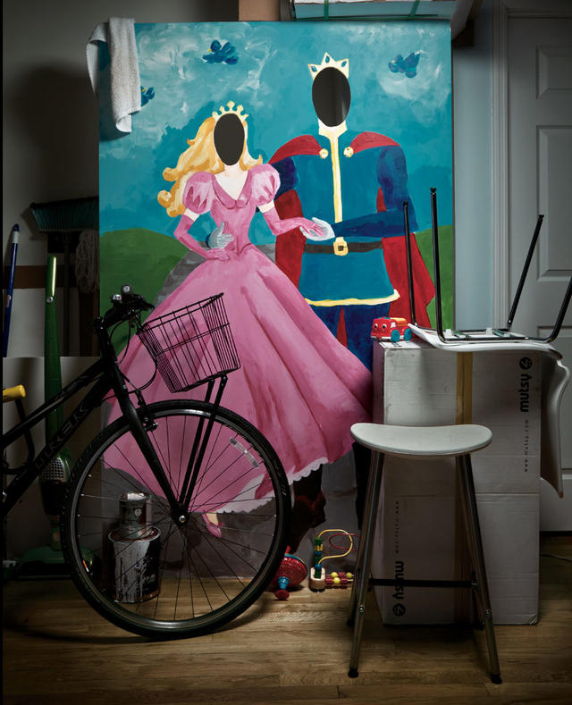
Perhaps it is the greatest marketing slogan of all time, writ larger than life in our Declaration, applied to an entire citizenry: "the pursuit of happiness." Over generations of prosperity and growth, the American Dream has become an American Expectation—a version of happiness achieved by entitlement and equation: Two fat incomes plus a two-car garage plus two master-bathroom sinks plus two-point-something kids equals one happy family. To be sure, the recession has deferred some of the dream. Still, we imagine that in time we'll realize the formula for a satisfied adulthood once more. We'll land the job, catch the spouse, buy the house, have the kids. In short, we'll live the better life.

But a raft of reports on well-being, including the World Values Survey and the General Social Survey of the National Opinion Research Center, suggest it's not better at all. We the people have grown continuously more depressed over the last half-century. A recent analysis of the World Database of Happiness, covering the years 1946 to 2006, found rising happiness levels in 19 of 26 countries around the world; the United States was not one of them. As Andrew Oswald, who studies the intersection of economics and happiness at the University of Warwick, in Britain, states, "The U.S.A. has, in aggregate, apparently become more miserable over the last quarter of a century."
Oswald and many other behavioral researchers say much of our discontent seems linked to the unrealistic expectations of the American Dream.
Increasingly, America deifies the nuclear family. It's the psychological and economic basis for this whole grand experiment in living. You get married, but social scientists have found that a poor marriage may be worse than staying single, and that the state of our unions—in the words of one massive new study—is "fragile and weak." You have children, but surveys have discovered more depression and unhappiness in adults with kids than in those without. You spend more hours at the office than almost any workforce in the world to pay for the big suburban house, but in exchange you suffer a commute that makes you miserable and a social isolation that puts more pressure on home life than even a McMansion can bear. In a 1966 essay in the Saturday Evening Post, Joan Didion pilloried those who had achieved the American Dream. "They had achieved the bigger house on the better street and the familiar accoutrements of a family on its way up," she wrote, and "they were paying the familiar price for it." That price seems to have risen in recent years, as if by inflation. And by investing so much well-being in our little slice of suburbia, to the exclusion of the greater community, the dream may be pushing families up the path to an increasingly elusive summit.

You Get Married
When I ask Jean Twenge about marriage and happiness, the psychology professor at San Diego State University tells me about her grandmother. She ran a farm, gave birth to seven children, and was married to her husband until he died, shortly after their 51st anniversary. It was a good marriage, by all accounts. "But she would have laughed in my face if I had asked her, 'Was he your best friend?'" Twenge says. "Now we expect our marriage partner to be our best friend and a great lover, a great parent and a soul mate, really-good-looking and have a great sense of humor. We have these expectations for marriage we can't possibly fulfill."
Americans cycle through relationships at exceptionally high rates. Though lower since the recession, divorce rates in the United States are still the highest in the West. And staying together is often no better. The percentage of Americans unhappy in their marriages is a full 10 points higher today than it was in polls 30-odd years ago, according to the latest annual "State of Our Unions" report on family life, a joint publication from the National Marriage Project at the University of Virginia and the Center for Marriage and Families at the Institute for American Values. The report cites the 2008 National Survey of Family Growth, which found that when asked whether "marriage has not worked out for most people they know," 37 percent of people agreed. A child born to unmarried cohabitating parents in Sweden has a better chance of living with both parents at 16 than a kid born to married parents in the United States.
Of course, Sweden—which vies annually with Denmark for the prize of "happiest country" in the World Values Survey—has a bounty of social policies that reduce the pressures of parenting, homeownership, health care, and neither an indigenous equivalent to Carrie Bradshaw nor a tradition of hundred-thousand-dollar weddings to fetishize the joining of two souls. "Here we look to that incredible emotional rush when you've just fallen in love, which we know physiologically doesn't stay that way—it can't," says sociologist Linda Waite, who studies marriage at the University of Chicago.
That said, social scientists, Waite included, have long found marriage to be associated with high levels of happiness and a strong positive effect on longevity. But a recent reevaluation of marriage-and-happiness research, conducted by Australian researchers Bruce Chapman and Cahit Guven, found that the two things don't always go hand in hand. After all, the researchers wondered, if marriage makes us so happy, why is there so much divorce? By reanalyzing the data they found that while people in self-assessed "good" marriages are certainly happy, those in "bad" marriages are less happy than other married couples as well as unmarried people. For anyone who has been unhappily married, these findings may smack of a profound truth obscured by those who cheerlead for lifetime commitment by any means necessary.
But coupledom doesn't necessarily spawn the American Dream, after all. And children turn couples into families. While "poor" marriages aren't better for one's mental health, Waite contends that all marriages are better for children than divorce (outside of abusive cases). "It's wiser to ignore your kids and focus on your relationship than to focus on your kids and ignore your relationship," she says. Of course, as she's quick to point out, that's not what we do. In fact, far too often, we do just the opposite.

You Have Kids
Carol Graham knows just how kid-centric Americans can be. Graham, who studies well-being at the Brookings Institution, in Washington, D.C., was raised in Peru by a Swiss mother. Both her research and personal experience suggest that emphasis on children is one of the major differences between families in America and those in other countries. "In other societies, kids fit into the family; parents are in charge," Graham says. "Here, the norm is that you're out of control of your life and spend every Saturday going to 59 birthday parties. You don't walk into homes elsewhere and find the kid standing on the coffee table." This child-centric style of parenting results in an adulthood divorced from extra-professional peer relationships. The autonomy and agency of American adults is ceded to children.
In studies that ask people to keep daily diaries of their well-being, psychologists have found that European parents report far more pleasurable experiences than their U.S. counterparts do. Of course, throughout the European Union, the state funds child care, pediatric visits, lengthy maternity—and often paternity—leaves, and so on. (Ring the alarm bells of socialism if you like, but it seems to be working at the level of the individual.) Tamar Kremer-Sadlik at the UCLA Center on the Everyday Lives of Families, who has done a comparative, self-reported diary study of hundreds of U.S. and Italian families, told me that only in the States do parents "see it as their own individual problem, not a structural problem, and that they're individual failures."
If you search for the term "family time" in American Google, Kremer-Sadlik points out, you'll find hundreds of thousands of entries. If you do it in Italian Google, she says, you'll find none. In their diaries, Kremer-Sadlik found, American parents wrote about Chuck E. Cheese, PG movies, and turning down plans to make space for "family time." Nothing like this arose in the entries from Italian parents, whose diaries described dinner at eight—in the company of children, yes, but also friends with children, and even friends without children. "It's an ideology here that you don't plan to be with others when you plan to be with your family," Kremer-Sadlik says. "American adults don't have a social life of their own; they don't hang out as people."
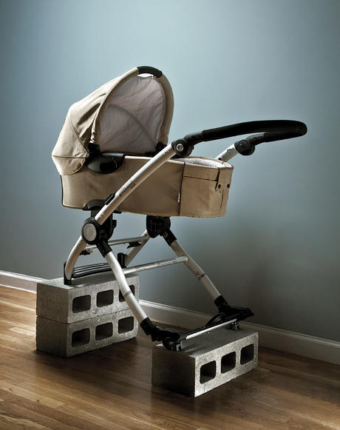
The American tendency to overfocus on kids may explain a large part of why parents report so much distress surrounding child-rearing. Robin Simon of Wake Forest University surveyed well-being data from 13,000 respondents and, in a 2005 issue of The Journal of Health and Social Behavior, published her findings that adults with children experience depression and unhappiness in greater numbers than nonparents. That's regardless of class, race, or gender. Simon understands this phenomenon as a ruthless combination of social isolation, lack of outside support, and the anticipation of the overflow of bliss that we believe is the certain outcome of every birth. "Our expectations that children guarantee a life filled with happiness, joy, excitement, contentment, satisfaction, and pride are an additional, though hidden, source of stress for all parents," she later wrote in Contexts magazine.
The relentless focus on the nuclear family seems to be increasing as women wait longer and longer to have children. Jean Twenge has found that the newest generation of parents— America's oldest yet—experiences the greatest level of dissatisfaction. "You had this time to live your life," she says. "You know what you're missing."
As someone who waited until my mid-30s to have a kid, I sure do. Motherhood hasn't magically cured me of my desire to see movies, go to rock shows, or stay out late with friends. And those parents who live in a cul-de-sac just a highway exit or two from a strip mall might be the first to admit they're experiencing an American dream that may be less Norman Rockwell than Revolutionary Road.

You Move To The Suburbs
Over half of Americans live not just in the suburbs but in true sprawl. Suburbs were imagined to be more land, more choice, more freedom. Instead, we're stuck on the highway or striding through a parking lot that stretches from Wal-Mart to the horizon. "Sprawl is the collapse of suburbia, the betrayal of the promise," says Andres Duany, coauthor ofSuburban Nation: The Rise of Sprawl and the Decline of the American Dream. The disconnect between "suburban expectation"—the idea of building a family and a community in a tamed expanse of land—and the blighted reality of sprawl explains much of our national dissatisfaction, says Duany. Add to that, he says, the loss of authentic connections that comes from the distinctly American notion of homeownership that plays a key part in fulfilling the dream: you purchase a private realm—your home—to replace a public sphere that no longer exists.
Today's houses are "fully equipped to compensate and mitigate the loss of the public realm," Duany says. Fifty years ago homes averaged 1,700 square feet. Now that figure is up to 2,700, and interior architecture, in Duany's mind, exists to mimic an urban world where few Americans dwell today. The double-height entry hall is the surrogate of the town square; the media room supplants the theater; the master suite practically exists as its own townhouse. Multiple dining areas further service our separation from the outside world: The breakfast nook is the diner; the formal dining room is the special-occasion white-tablecloth restaurant; even the kitchen island functions like a European tabac. "If you had a public realm," Duany says, "you wouldn't have to buy more house." Duany's own work in the New Urbanist movement—planning walkable, mixed-use areas designed to recapture a sense of community—may be the best bet for a resurgence of the public realm. But even a semi-utopian like Duany has a hard time imagining how to reverse the course of American sprawl en masse.
Of course, we've been rocketing toward this point for decades now. The growth of the interstate highway system in the 1950s and '60s accelerated the surge to the suburbs; the car, as Duany says, "has become a prosthetic device." And so we spend our lives ferrying between cubicle and soccer practice, with nary an hour to spare. Not only is all that over-scheduling making us unhappy, but the actual commuting itself is a misery. In 2008, Swiss economists Alois Stutzer and Bruno Frey discovered the so-called "commuting paradox." While people gladly trade a longer daily commute for a bigger home in the suburbs, Stutzer and Frey found a direct link between long drives to work and low well-being. In fact, they reported that people who commute roughly 45 minutes each day have to earn 19 percent more a month than they already do to make the trip worthwhile.
It's not just the bummer of getting to work, it's the reality of staying there. Americans have the longest workweek in the developed world. In Norway and the Netherlands, workers clock in 1,400 hours per year. Americans, meanwhile, average 1,900 hours. In fact, we spend more time at the office than the citizens of any other industrialized country— and all but two developing nations.
But a strong work ethic—and the freedom to spend its returns on whatever we please—is exactly what has given rise to the best of the American Dream, rendering a Canaan out of this land for hopeful immigrants around the world. What could be the issue with all that honorable labor? Plenty, says psychologist Tim Kasser of Knox College, whose recent work has found a negative correlation between the number of hours a person works and life satisfaction. "The more people focus on a materialistic pathway to happiness, the less happy they tend to be, and the less happy they make others," he says.
Over time this devotion to earning income detracts from pursuits that might reduce this misery, such as forging strong relationships. Kasser argues that a materialistic drive actually damages our ability to form personal bonds—causing us to "treat other people as objects to be manipulated rather than as unique individuals with their own desire, needs, and subjective experiences." In other words, the more we focus on accumulating things, the harder it becomes to drop these things and focus on people.
It's a vicious cycle: Overinvestment in the nuclear family, and rigid ideas about how to shelter and school our kids, requires more time at work to pay for the needs of the family, and extra estrangement from the world at large. That explains why mothers and fathers spent more time both at the office and with their children in 2009 than they did in 1975, according to the American Time Use Survey from the Bureau of Labor Statistics. It's a treadmill locked on a setting that never lets us catch our breath or consider how we started running so fast in the first place.
And the more we strive to meet the expectations of the American Dream, the increasingly elusive happiness becomes, says Jean Twenge. "It's particularly American, an unwillingness to compromise built into our individualism, imagining what our lives are supposed to be," Twenge says. "And when you say I'm always supposed to be excited, then there's a vast underbelly of discontent. It's gotten to a level of delusion."

You Dream On
When I was pregnant, a dear friend gave me a book with a card that said, "Read this instead of What to Expect When You're Expecting." The book was A Life's Work, British novelist Rachel Cusk's memoir of early motherhood. "I arrived at motherhood shocked and unprepared, ignorant of what the consequences of this arrival would be, and with the unfounded but distinct impression that my journey there has been at once so random and so determined by forces greater than myself that I could hardly be said to have had any choice in the matter at all," Cusk growls from the page. At times I've felt that way. And if you're a parent, I imagine you have too.
"Why does no one tell us adulthood would be like this?" I recently whined to a friend. "Adulthood?" she scoffed. "There's no such thing as adulthood." She has a point. This dream of arriving at some destination of deep fulfillment—a place where parenting will give profound joy and satisfaction; where the romance of partnership is eternal; where making a home payment on the first of every month is a source of pride and not anxiety—is often no more than that: a dream. A faith, almost—something not even the best social science is likely to corrupt. It may be impossible to awaken from the American Dream. But by adjusting our expectations, and recognizing that one must balance pleasure and sacrifice, perhaps we can at least have an honest conversation about when the dream is, and is not, worth chasing.

